CREATE IBM CLOUD ACCOUNT

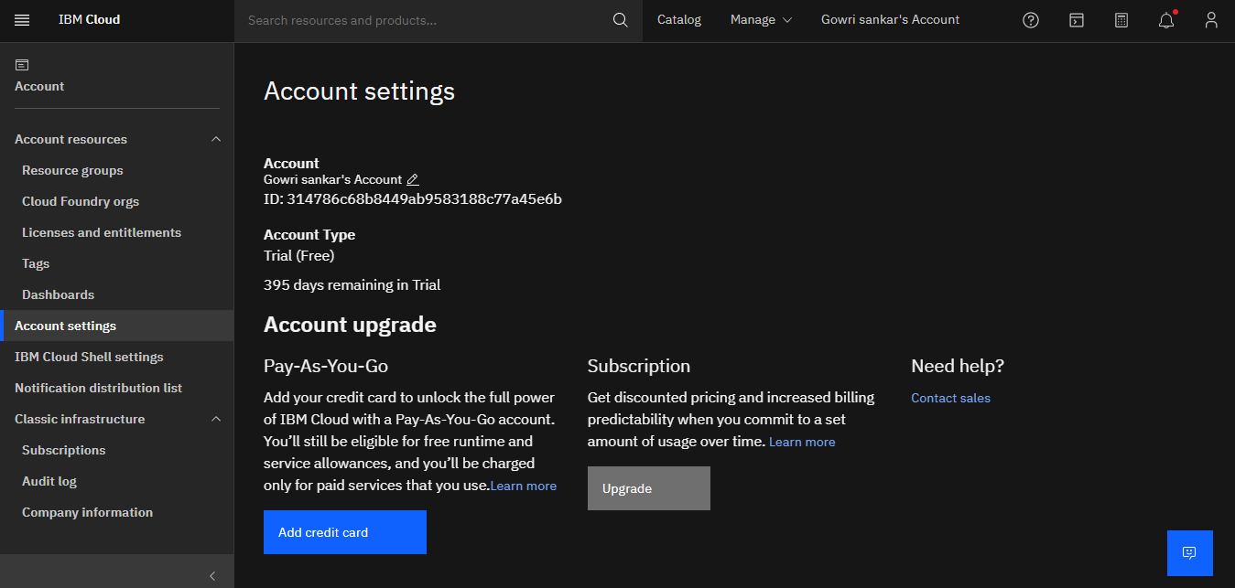

DOCKER CLI INSTALLATION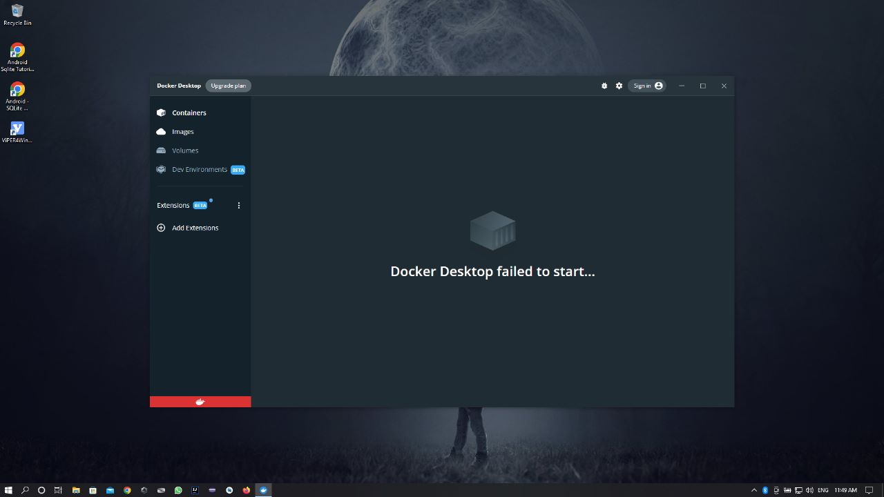

CREATE AN ACCOUNT IN SENDGRID

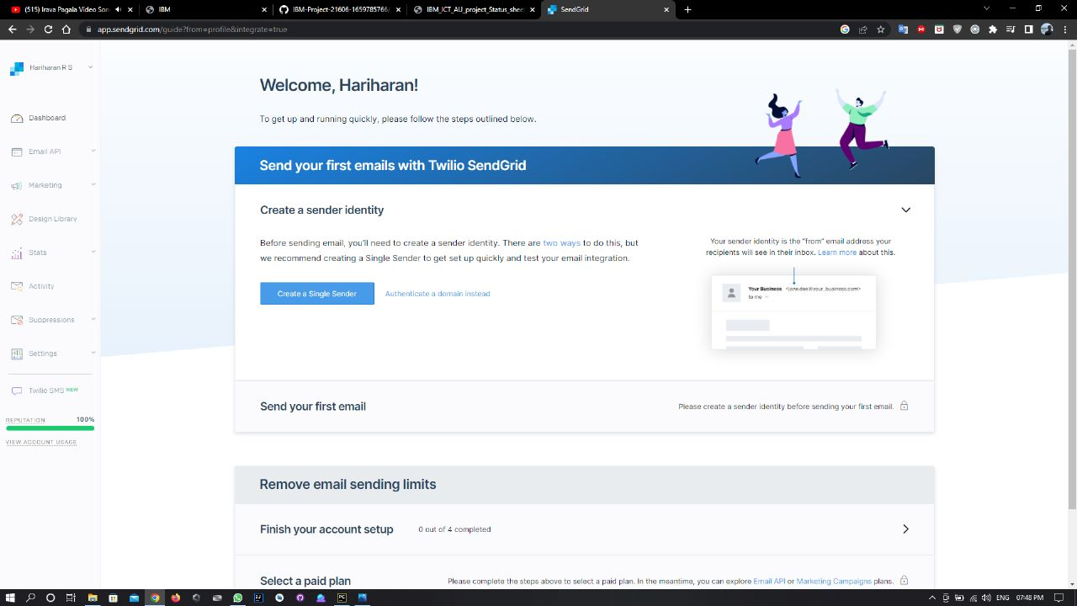

INSTALL IBM CLOUD CLI

